**INSTITUTE OF ENGINEERING**

**ADVANCED COLLEGE OF ENGINEERING AND MANAGEMENT**

**KUPONDOLE, LALITPUR**

**(AFFILIATED TO TRIBHUVAN UNIVERSITY)**



LAB REPORT

LAB NO: 3

SUBJECT: Computer Network

**SUBMITTED BY:** **SUBMITTED TO:**

NAME: Pramesh Mahat

ROLL NO: ACE074BCT041

DATE: 20th June, 2021

Department of Computer & Electronics

**Signature:**

Sameer Sitoula

**Title: Dynamic Routing using RIP and EIGRP**

**Objective:** To learn about basic concept of dynamic routing

**Introduction :**

Dynamic Routing: Dynamic routing, also called adaptive routing, is a process where a router can forward data via a different route or given destination based on the current conditions of the communication circuits within a system. The term is most commonly associated with data networking to describe the capability of a network to 'route around' damage, such as loss of a node or a connection between nodes, so long as other path choices are available. Dynamic routing allows as many routes as possible to remain valid in response to the change. There are several protocols that can be used for dynamic routing. Routing Information Protocol(RIP) is a distance-vector routing protocols that prevents routing loops by implementing a limit on the number of hops allowed in a path from source to destination. Open Shortest Path First (OSPF) uses a link state routing (LSR) algorithm and falls into the group of interior gateway protocols (IGPs). Intermediate System to Intermediate System (IS-IS) determines the best route for data through a packet-switched network. Interior Gateway Routing Protocol (IGRP) and its advanced form Enhanced Interior Gateway Routing Protocol (EIGRP) are used by routers to exchange routing data within an autonomous system.

**RIP:** Routing Information Protocol(RIP) is a dynamic routing protocol which uses hop count as a routing metric to find the best path between the source and the destination network. It is a distance vector routing protocol which has AD value 120 and works on the application layer of OSI model. RIP uses port number 520.

**EIGRP:** Enhanced Interior Gateway Routing Protocol (EIGRP) is a dynamic routing Protocol which is used to find the best path between any two layer 3 device to deliver the packet. EIGRP works on network layer Protocol of osi model and uses the protocol number 88.It uses metric to find out best path between two layer 3 device (router or layer 3 switch) operating EIGRP. Enhanced Interior Gateway Routing Protocol (EIGRP) is a Cisco-proprietary hybrid routing protocol that contains features of distance-vector and link-state routing protocols. It is a network layer protocol which works on the protocol number 88.

**Design:**

In this lab there are 3 routers 1, 2, and 3 with 2 other laptops as host consisting 4 networks as shown in figure and laptop consists of IP of same network in which it is connected.

For RIP, Routers are connected with copper cross-over wires whereas for EIGRP, Routers are connected with serial DCE wires as we can see in the figures below.

**Using RIP**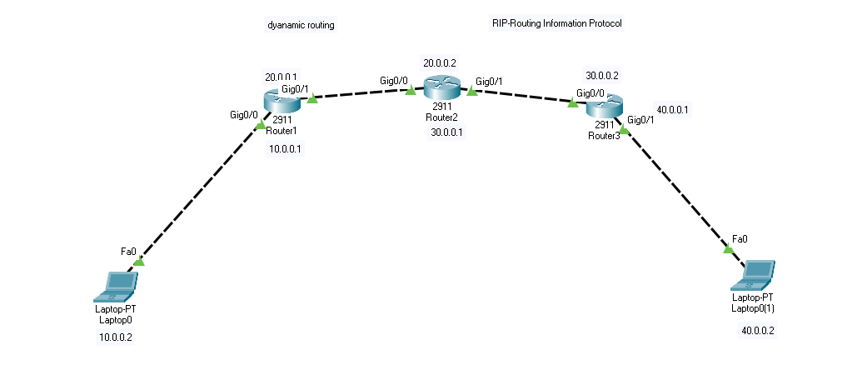

**Using EIGRP**

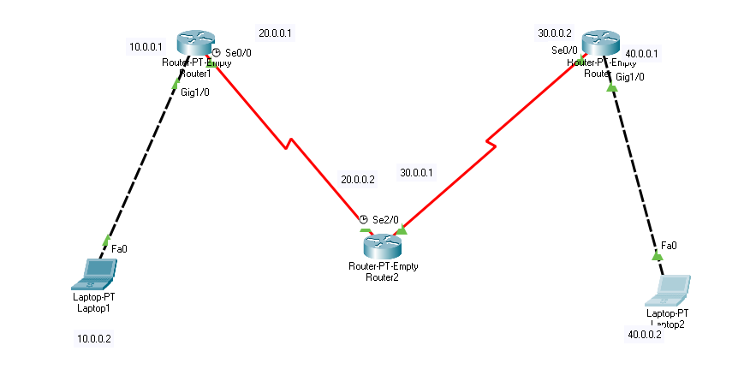

**Steps:** Various steps were involved while doing this lab after the completion of setting up of all devices and cables.

**For RIP**

Step 1: Setting up Routers Through commands

Commands for router 1

* en
* configure terminal
* interface gig0/0
* ip add 10.0.0.1 255.0.0.0
* no sh
* interface gig0/1
* ip add 20.0.0.1 255.0.0.0
* no sh
* router rip
* version 2
* network 10.0.0.0
* network 20.0.0.0
* exit
* do write

Commands for router 2

* en
* configure terminal
* interface gig0/0
* ip add 20.0.0.2 255.0.0.0
* no sh
* interface gig0/1
* ip add 30.0.0.1 255.0.0.0
* no sh
* router rip
* version 2
* network 20.0.0.0
* network 30.0.0.0
* exit
* do write

Commands for router 3

* en
* configure terminal
* interface gig0/0
* ip add 30.0.0.2 255.0.0.0
* no sh
* interface gig0/1
* ip add 40.0.0.1 255.0.0.0
* no sh
* router rip
* version 2
* network 30.0.0.0
* network 40.0.0.0
* exit
* do write

**Step 2:** Assigning the IP to laptops

Laptop 1:10.0.0.2

Laptop 2:40.0.0.2

**For Eigrp**

Step 1: After resetting all the configuration of above topology, IP is assigned to the all router and following commands are executed

For Router 1

* en
* configure terminal
* interface gig0/0
* ip add 10.0.0.1 255.0.0.0
* no sh
* interface gig0/1
* ip add 20.0.0.1 255.0.0.0
* no sh
* router eigrp 1
* network 10.0.0.0
* network 20.0.0.0
* exit
* do wr

For router 2

* en
* configure terminal
* interface gig0/0
* ip add 20.0.0.2 255.0.0.0
* no sh
* interface gig0/1
* ip add 30.0.0.1 255.0.0.0
* no sh
* router eigrp 1
* network 20.0.0.0
* network 30.0.0.0
* exit
* do wr

For router 3

* en
* configure terminal
* interface gig0/0
* ip add 30.0.0.2 255.0.0.0
* no sh
* interface gig0/1
* ip add 40.0.0.1 255.0.0.0
* no sh
* router eigrp 1
* network 30.0.0.0
* network 40.0.0.0
* exit
* do wr

**Output:** Output can be shown by pinging the host of another network

For RIP

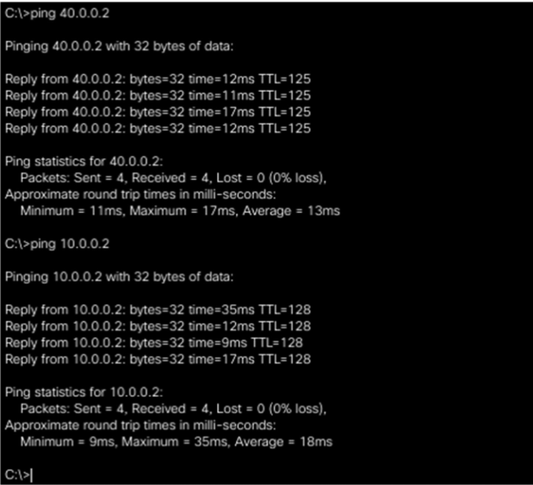

For EIGRP

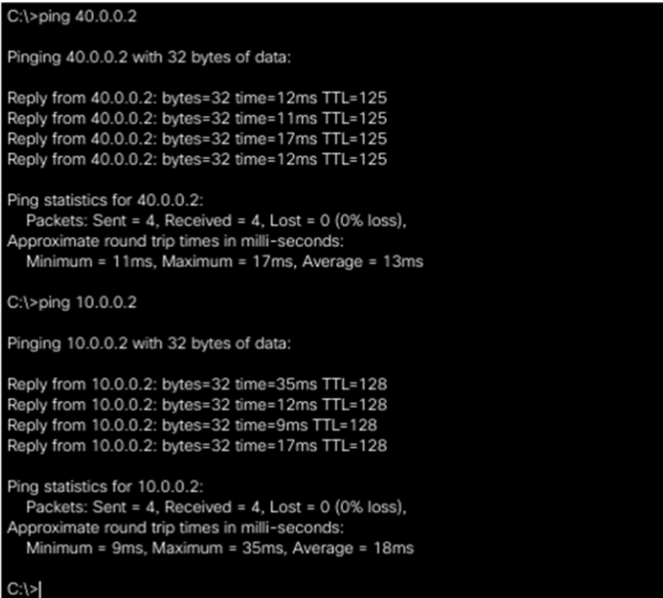

**Result and Conclusion:** In this lab we were able to communicate two devices of different network using dynamic routing through RIP and EIGRP protocol.